TCP Chapter1

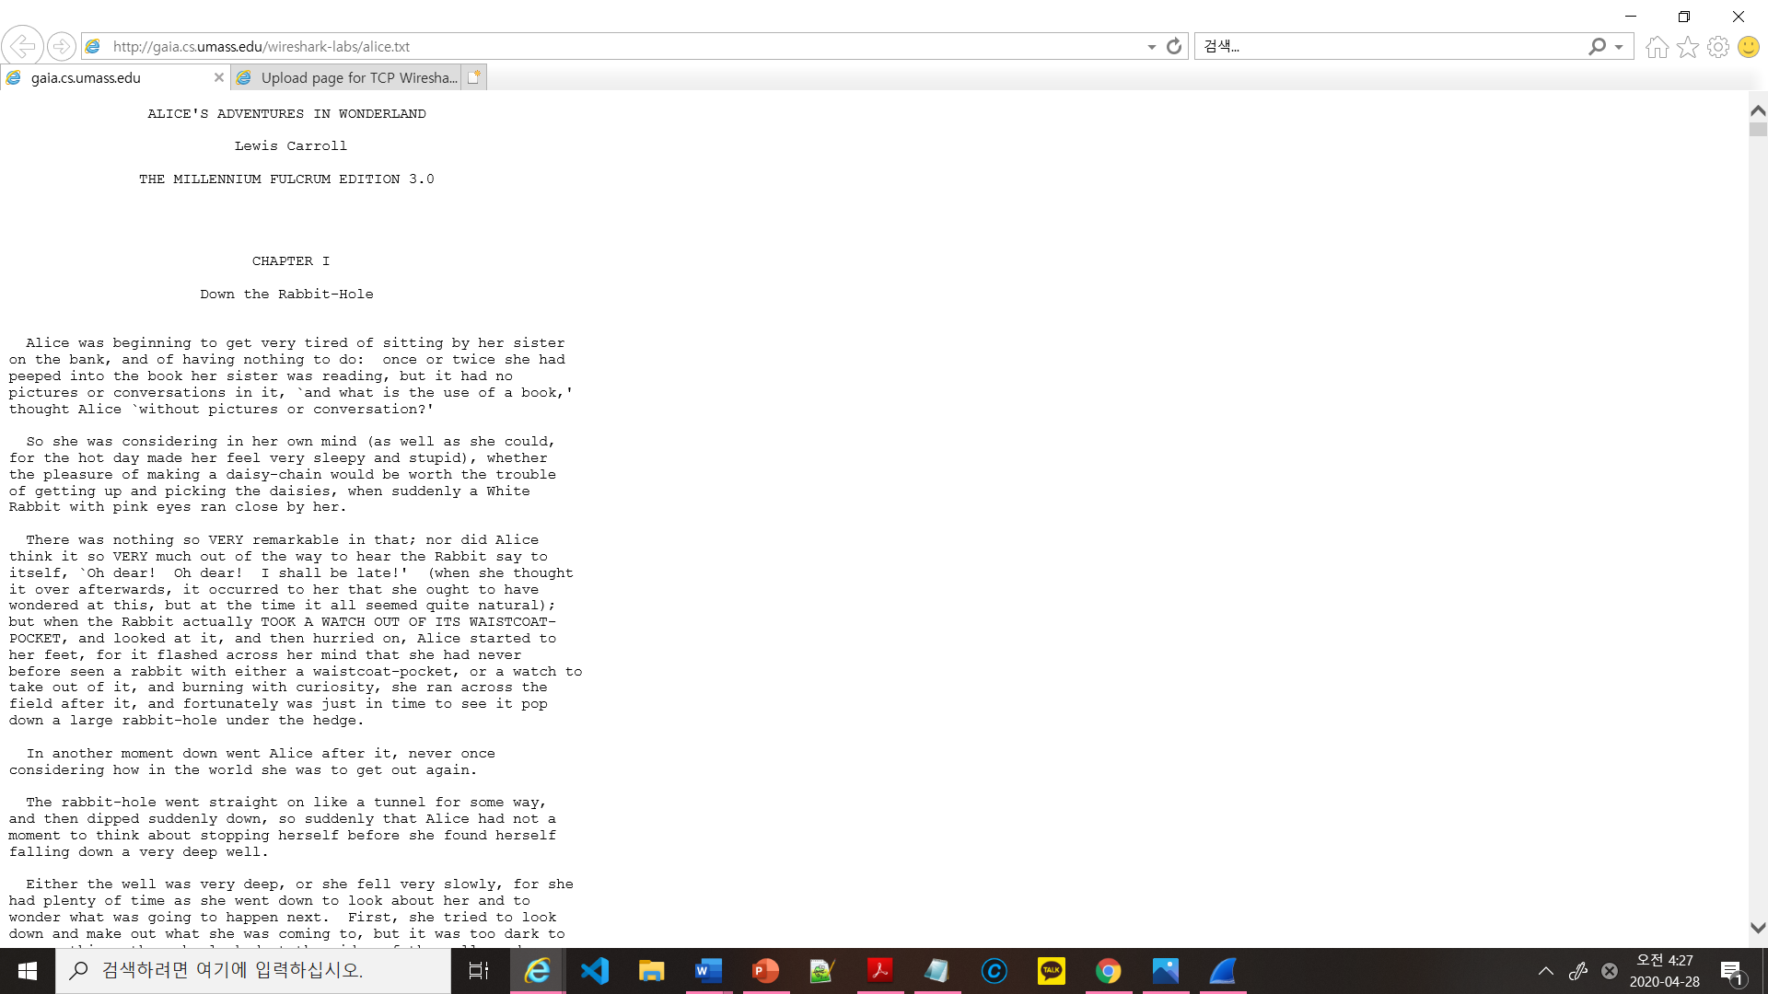

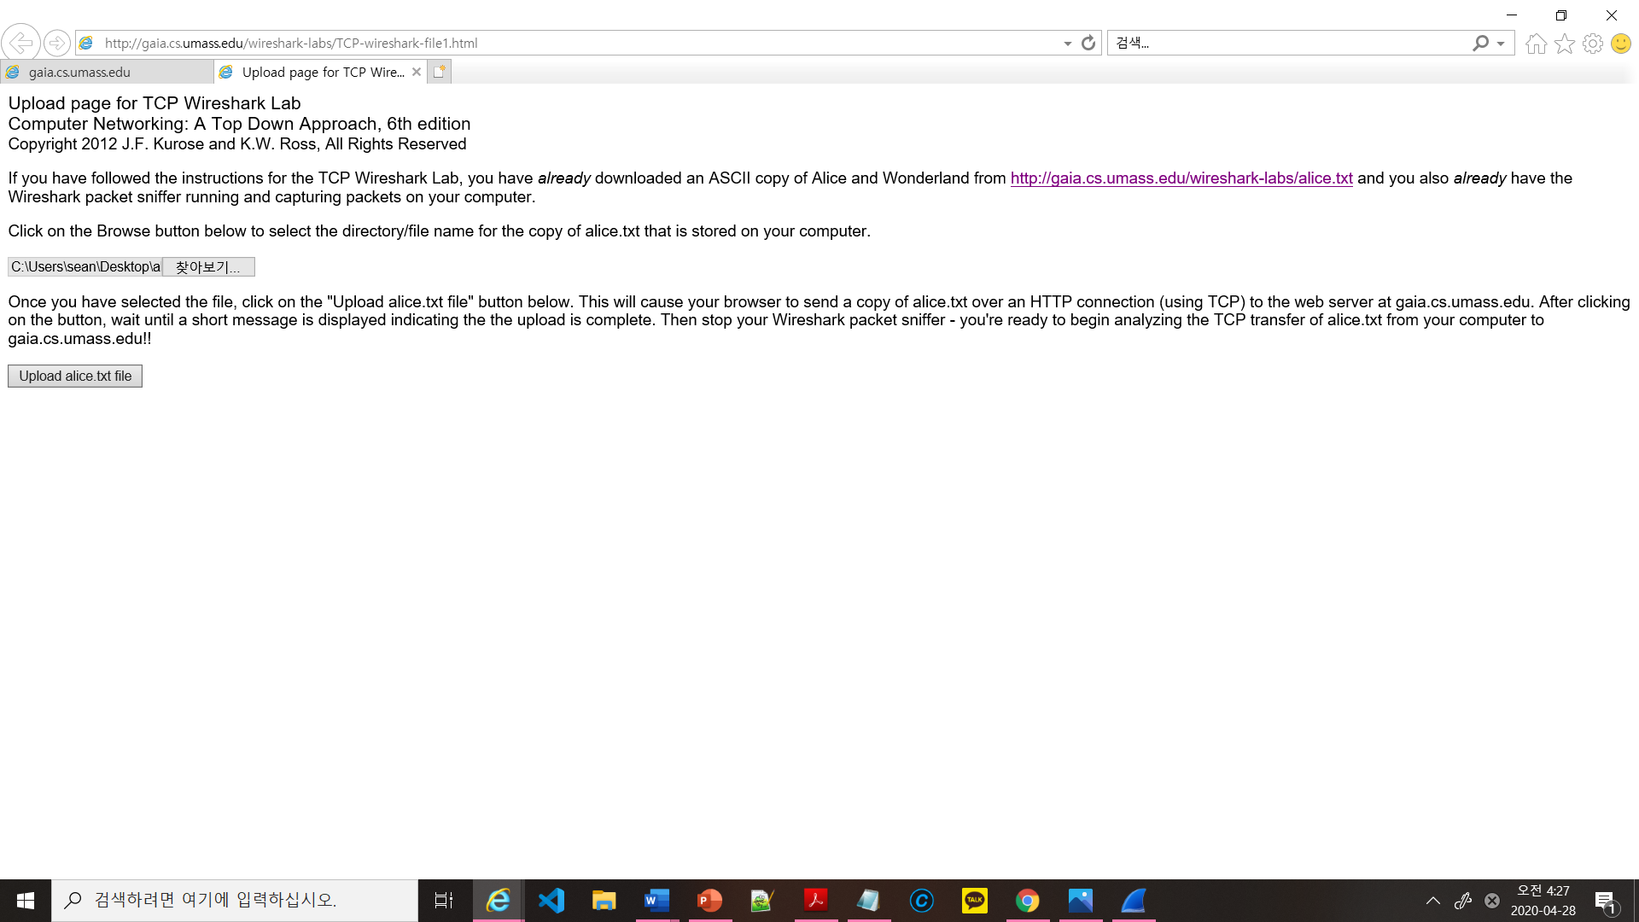

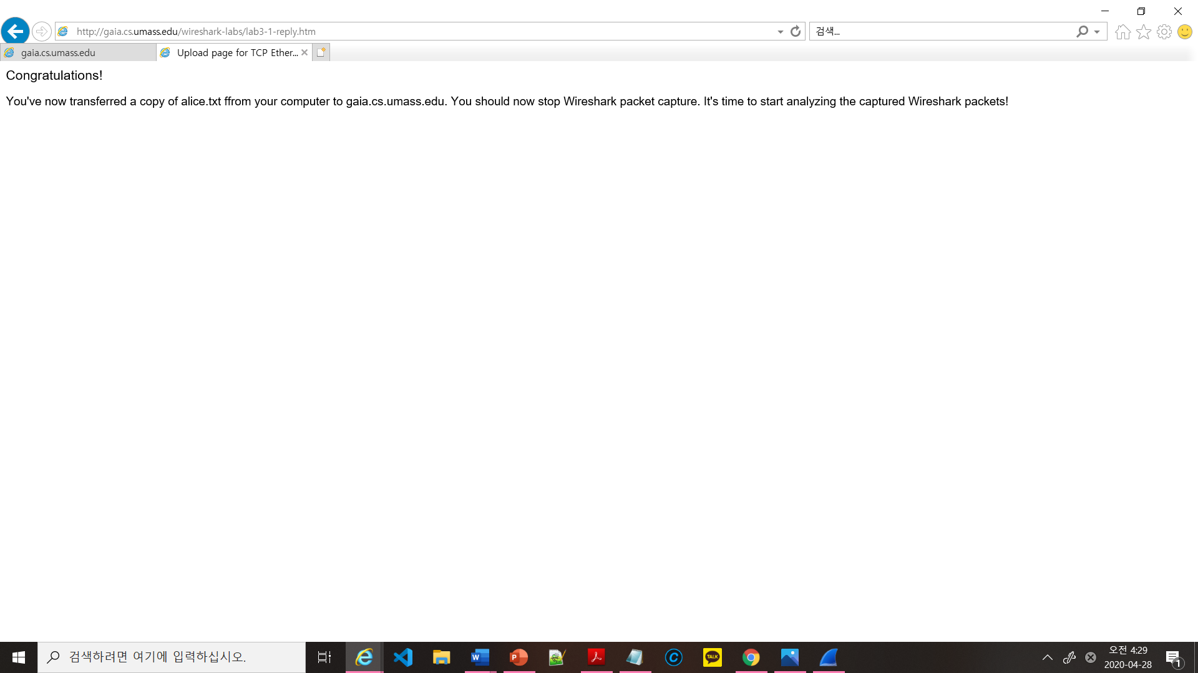

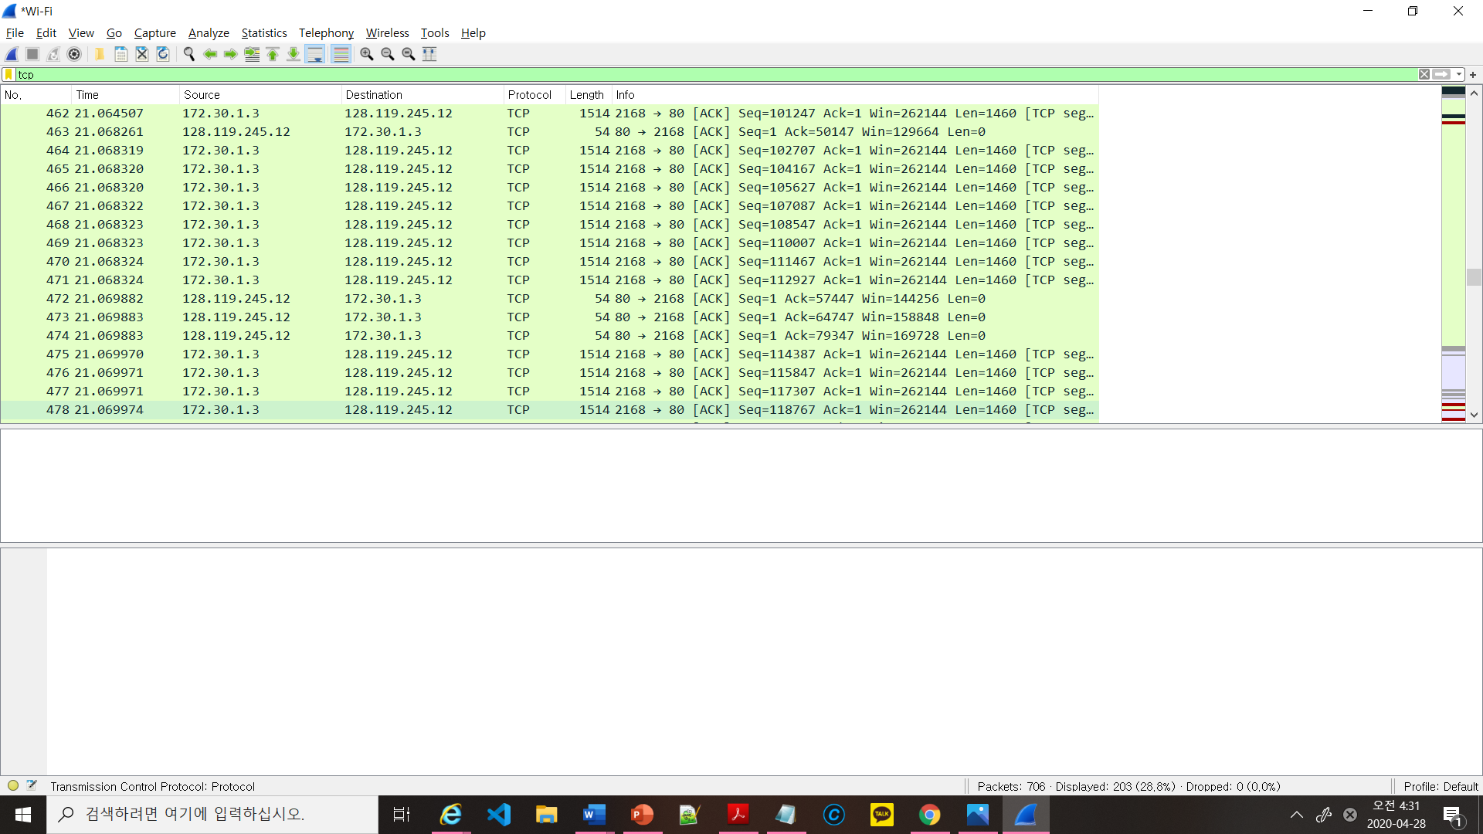

TCP Chapter2

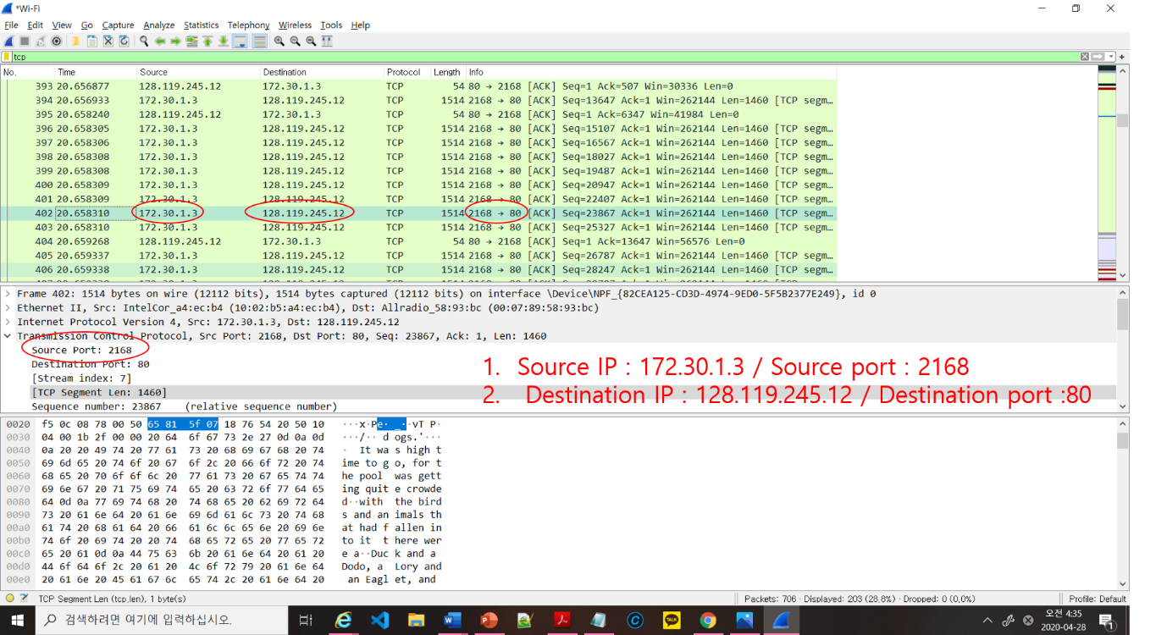

3. Source IP : 172.30.1.3 / Source port : 2168 / Destination IP : 128.119.245.12 / Destination port :80

TCP Chapter3

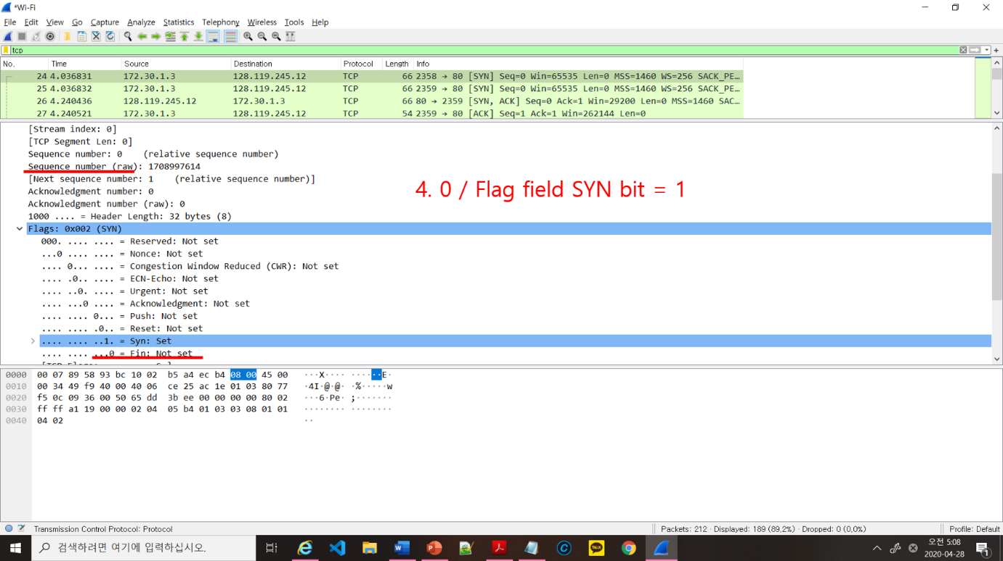

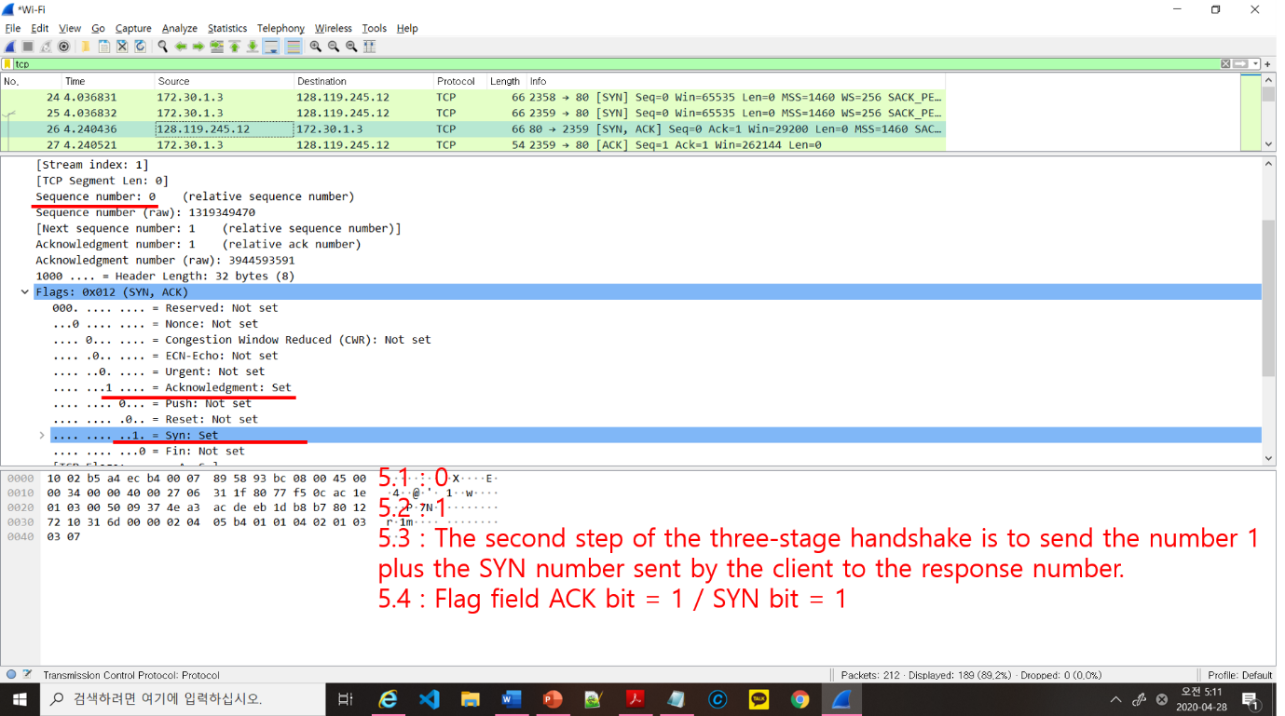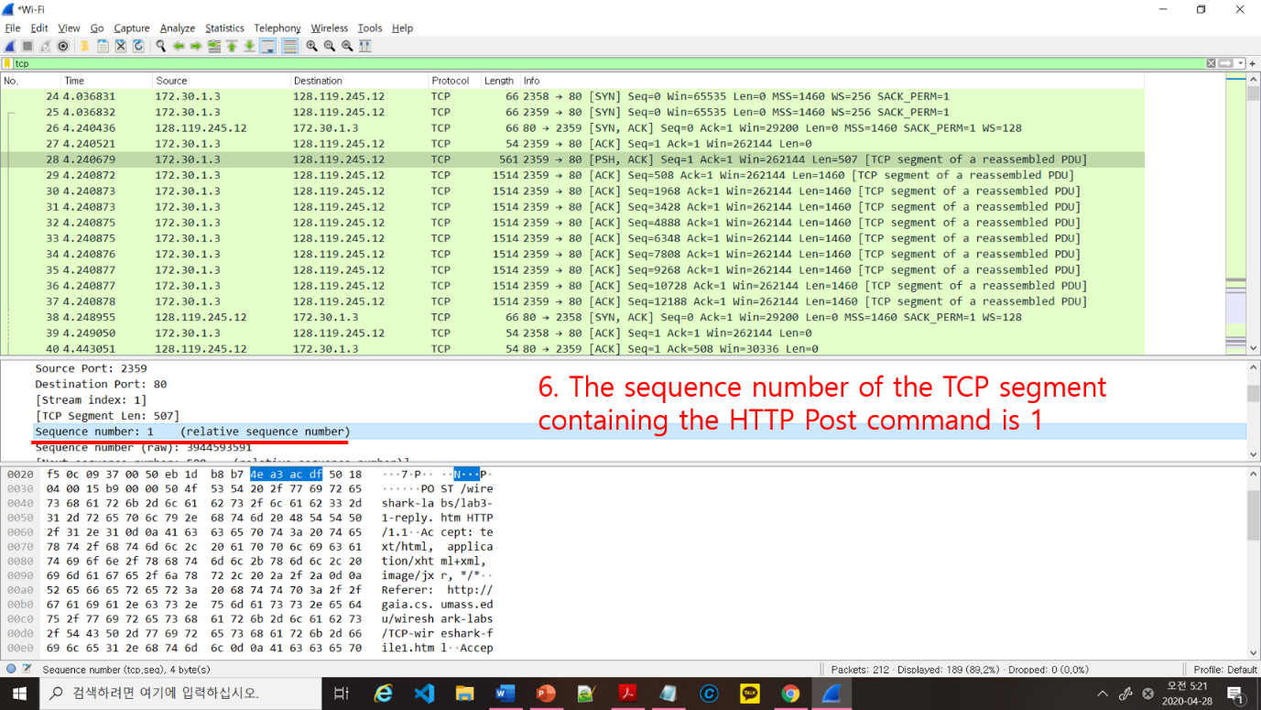

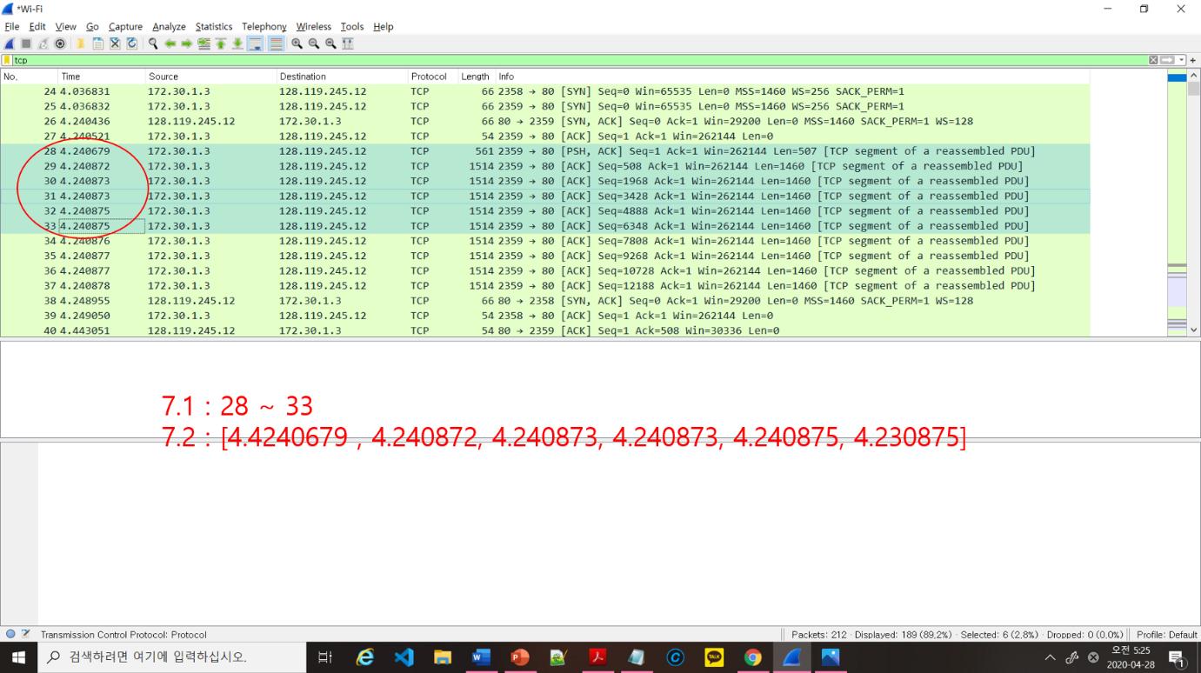

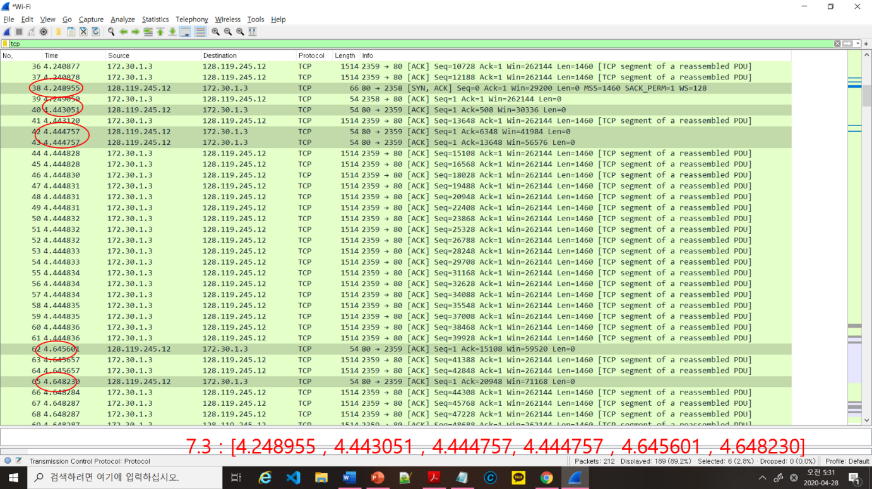

7.4 : 7.3 – 7.2

= [0.008276 , 0.202179, 0.203927, 0.203927, 0.404726, 0.417355]

7.5 EstimatedRTT(t) = (1 - a)\*EstimatedRTT(t-1)+ a\*SampleRTT(t) ( a = 0.125)

∴[0.02746, 0.265547375, 0.257844828125, 0.25110509960936‬, 0.2703077121582, 0.28868862313843]

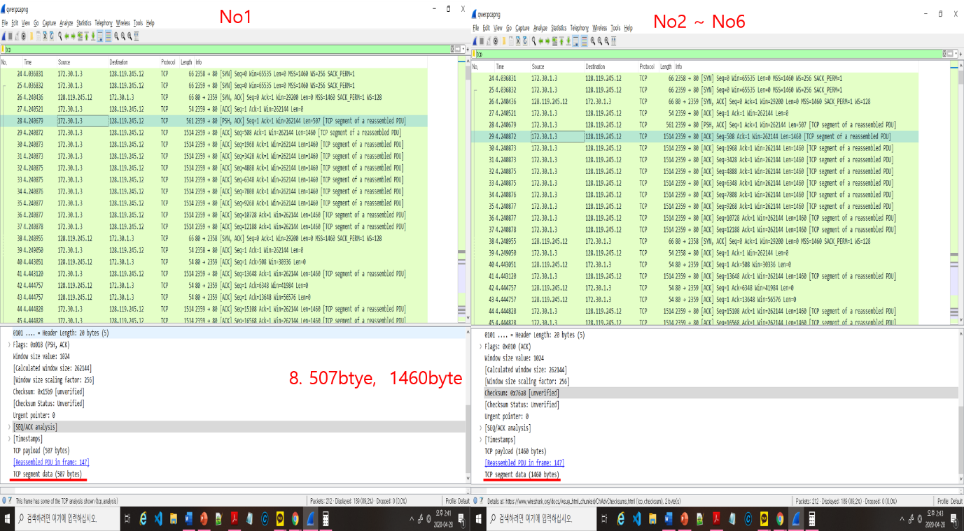

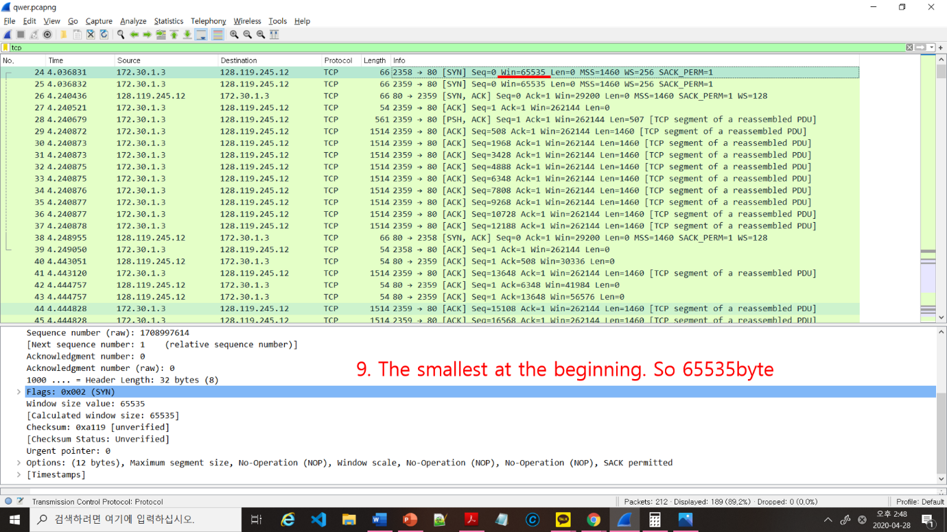

10 :

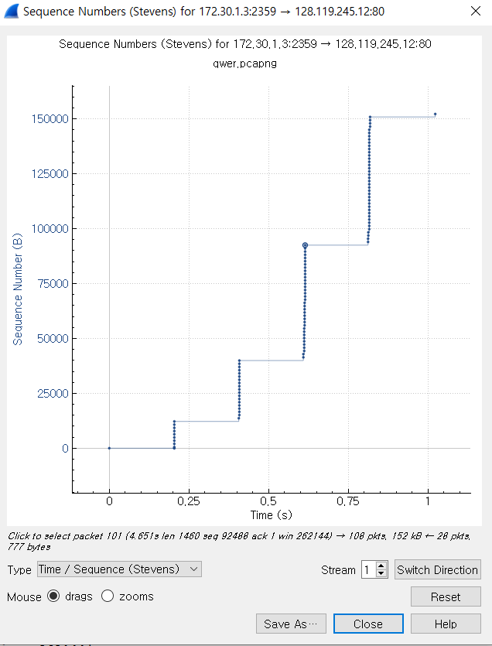

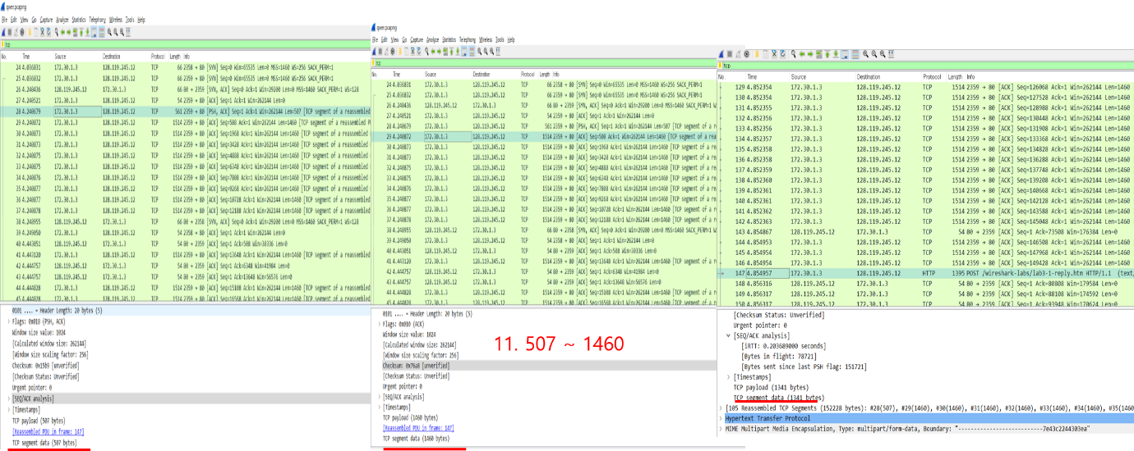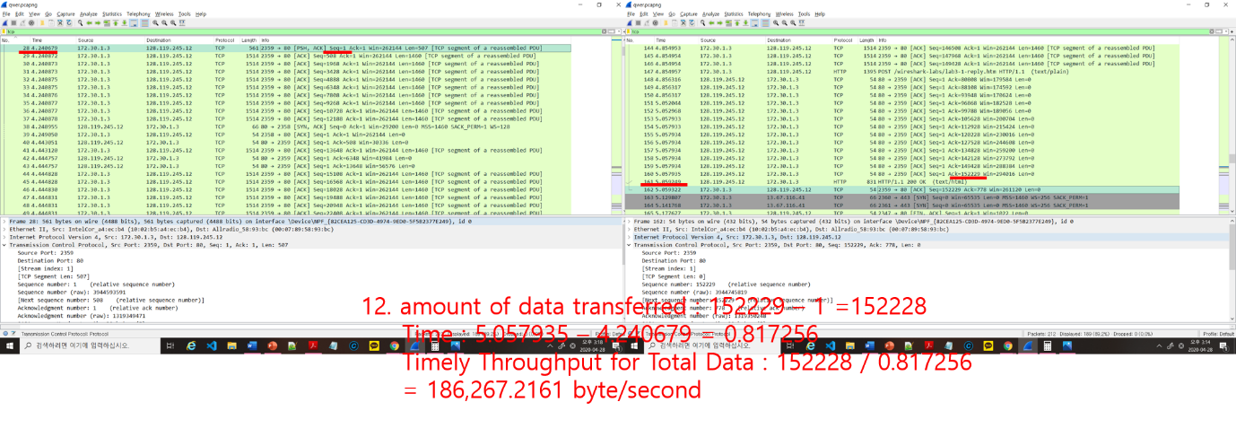TCP Chapter 5

13. The start of the 'slowstart' phase can be found at the signal No.28. However, since maximum transmission is limited by the application, it is not possible to identify where 'slowstart' ends and where congestion begins as data transmission is suspended. / Check the status of the sender by identifying the variation in the crowded window size when ACK signals arrive.

14. The step of starting 'slowstart' can be found in the transmission of 'HTTP POST'. However, there is no end to the slow start and so does not start the congestion avoidance because of the 'slowstart' of the two TCP communications that continues uninterrupted and remain this state until the data transfer is complete. / Unlike the traditional method of sending SEQ and ACK signals one by one by one, the collection of each packet is determined through the method called "TCP segment of a reserved PDU" and it is divided and transmitted by packet.